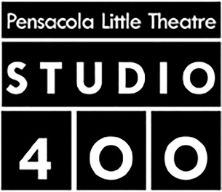
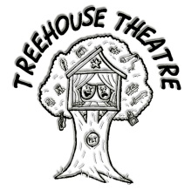
MID-SHOW EVALUATION FORM
(OR, HOW ARE WE DOING SO FAR?)

NAME OF THE SHOW: SHORT ATTENTION SPAN THEATRE
YOUR NAME (optional): ____________________________________

HAS THIS SHOW BEEN A POSITIVE EXPERIENCE? YES NO

WHAT DO YOU LIKE? (Please let us know what you like about the rehearsal process so far. Is there anyone or anything that is making this show really enjoyable for you?)

WHAT CAN WE DO BETTER? (Please let us know if there is anything about the rehearsals you are not happy with. Is there anyone or anything that is preventing this show from being enjoyable? What can we do to make it better?)

Thank you for your feedback. We are always trying to grow and learn to make PLT the best it can be.
ENJOY THE REST OF THE SHOW!!

